**Senior Design I**

**EEL4914**

**University of Central Florida**

**Department of Electrical and Computer Engineering**

# **SMART Garden**

# Divide and Conquer 2.0

**Group 34**

**Ryan Hassan** **[CPE]**

**Kevin Lorch** **[CPE]**

**Lauren Melancon** **[EE]**

**Jonathan Wallhauser** **[CPE]**



**Table of Contents**

**1. Smart Garden**  **Page 3**

1.1 Motivation Page 3

1.2 Goals and Objectives Page 3

1.3 Function of the Project Page 3

**2. Requirement Specifications**  **Page 4**

2.1 Project Requirements Page 4

2.2 Project Specifications Page 5

2.3 Project Constraints Page 6

**3. Project Block Diagrams** **Page 6**

3.1 Software Block Diagram Page 6

3. 2 Power Supply Block Diagram Page 7

3. 3 Hardware Block Diagram Page 7

**4. Estimated Project Budget and Financing** **Page 8**

**5. House of Quality** **Page 9**

**6. Initial Project Milestone** **Page 10**

5.1 Senior Design I Page 10

5.2 Senior Design II Page 10

**7. Conclusion** **Page 11**

**1. Smart Garden**

**1.1 Motivation**

As inflation in the United States continues to rise, and global supply chain issues persist, working class people are finding it harder and harder to be able to find or afford healthy food options at their local grocery stores. In fact, according to Morning Consult's latest U.S. Supply Chains & Inflation report, over half (51%) of consumers surveyed in March 2022 reported experiencing product shortages of specific types of groceries and food, up from 43% in September 2021 ${}_{}^{\left[1\right]}{}$. With that being said, the looming fear of large-scale food scarcity coupled with the steadily declining economy have forced many Americans to turn to unhealthy food alternatives. The smart garden presents a small but impactful way to help counteract this issue and benefit the lives of those in need.

**1.2 Goals and Objectives**

* Portable
* Easy-to-use
* Automated
* Monitors condition of plants using sensors
* Mobile/Web application
* Information is delivered in an easily digestible form
* Decrease in required manual labor

**1.3 Function of Project**

* Collects data on soil moisture
* Collects data on temperature and humidity
* Offers a mobile app or web application interface for the user
* Portable with an easy setup
* LCD Display
* Offers a solar option using PV panels for rechargeable battery
* Water reservoir and nutrient dispenser
* Scheduling feature offered through web-based application
* Rechargeable battery and cost efficient
* Plant database with recommended soil moisture, temperature, watering schedule, and humidity settings
* Mobile app or web application that stores and displays data collected by sensors to the user

**2. Requirement Specifications**

**2.1 Project Requirements**

* The system shall be able to maintain accurate moisture levels in soil for the plant that is being maintained.
* Levels for moisture should have the ability to be fetched from plant specification database.
* Levels for humidity should have the ability to be fetched from plant specification database.
* Levels for temperature should have the ability to be fetched from plant specification database.
* Levels for sunlight should have the ability to be fetched from plant specification database.
* The system shall be able to read the sunlight levels being received by the plant and convey it to the End-User (EU).
* The system shall show all sensor information on the LCD display.

**2.2 Project Specifications**

|  |  |
| --- | --- |
| **Size Specifications** |  |
| Base | 12 Inches |
| Length | 8 Inches |
| Height | 24 Inches |
| **Accuracy** |  |
| Accurate readings | 90% of time |
| Optimal Conditions | 95% of time |
| **Battery Life** |  |
| Lithium Ion | 18 Hours |
| **Database Plants** |  |
| Herb | Cilantro |
| Herb | Basil |
| Herb | Parsley |
| Herb | Oregano |
| Herb | Sage |
| Vegetable | Carrot |
| Vegetable | Tomato |
| Vegetable | Potato |
| Vegetable | Green Onion |
| Vegetable | Kale |
| **Protype Plants to be Tested** |  |
| Herb | Cilantro |
| Herb | Basil |
| Herb | Oregano |

**Table 1: Project Specification**

**2.3 Project Constraints**

* The system must use a rechargeable and removable Lithium Ion Battery
* The system must make use of PV panels

**3. Project Block Diagrams**

**3.1 Software Block Diagram**

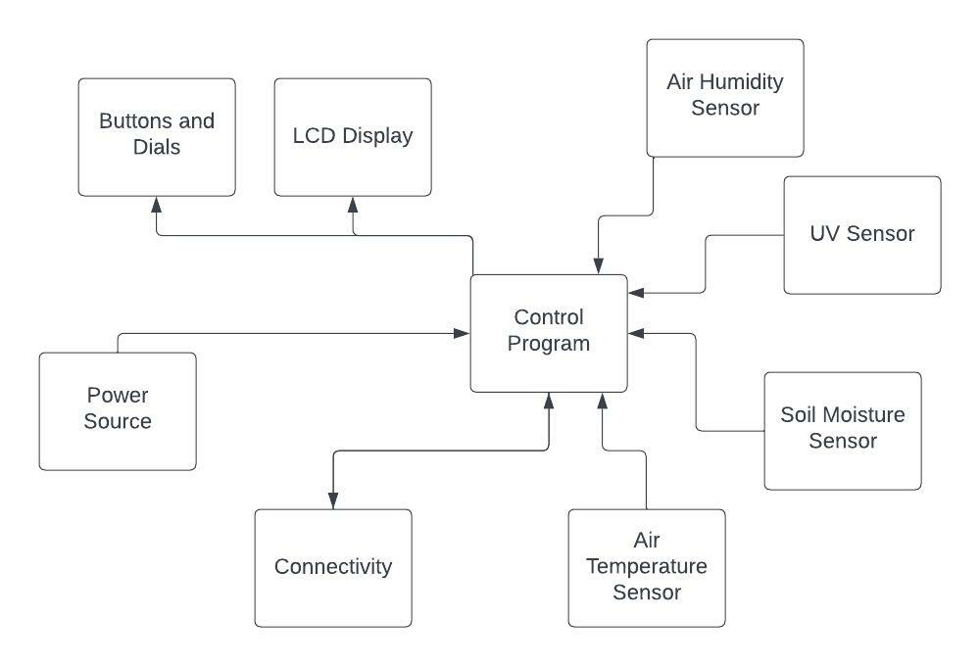

**Fig.1: Software Block Diagram**

**3.2 Power Supply Block Diagram**

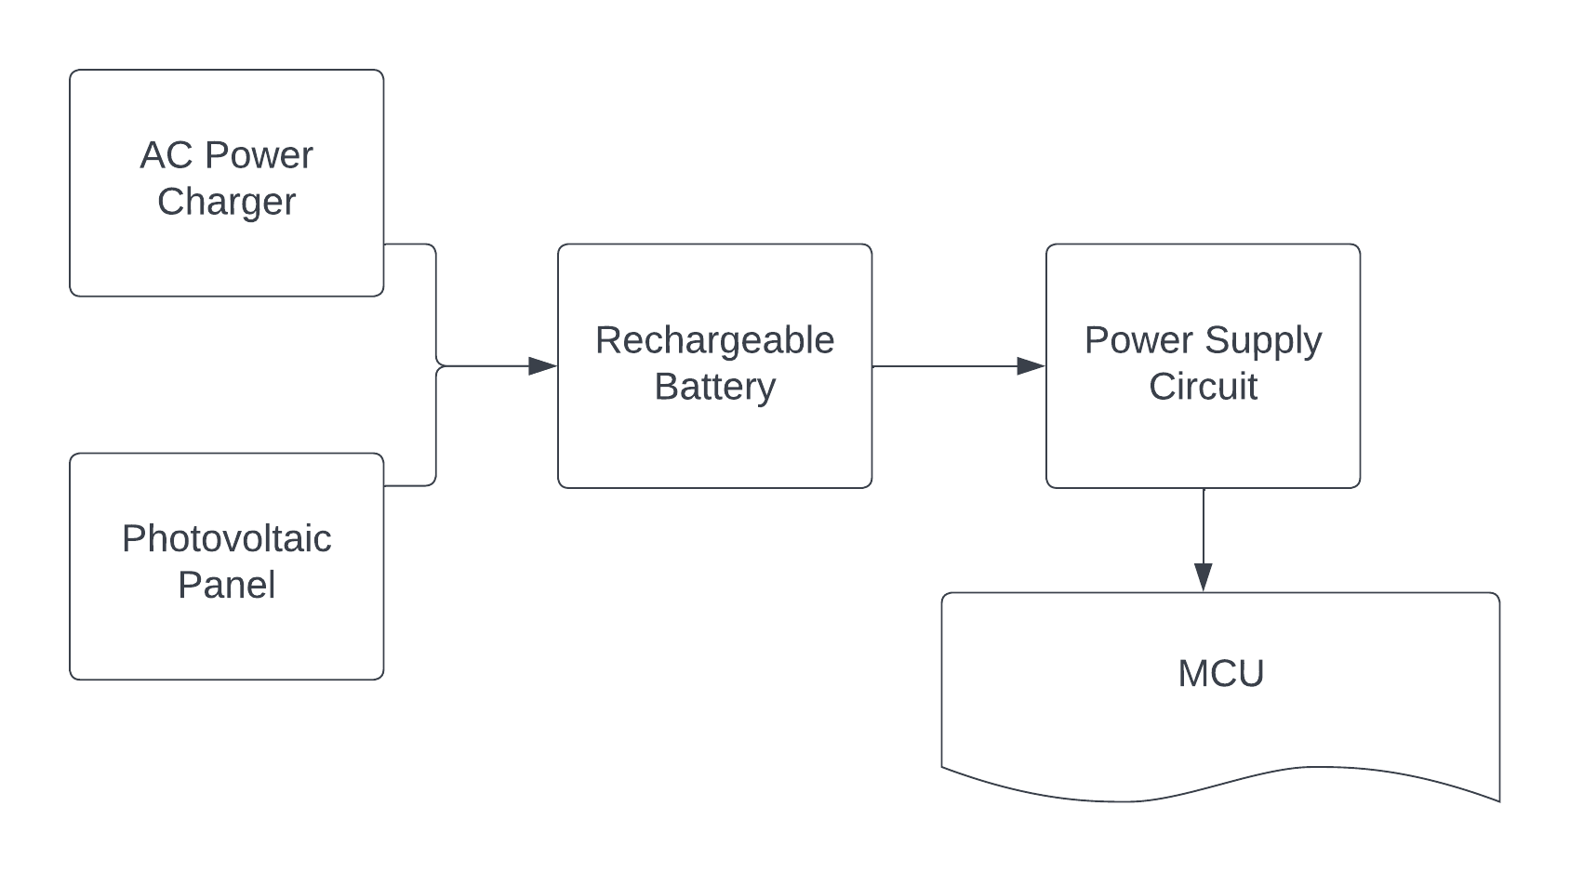

**Fig. 2: Power Supply Block Diagram**

**3.3 Hardware Block Diagram**

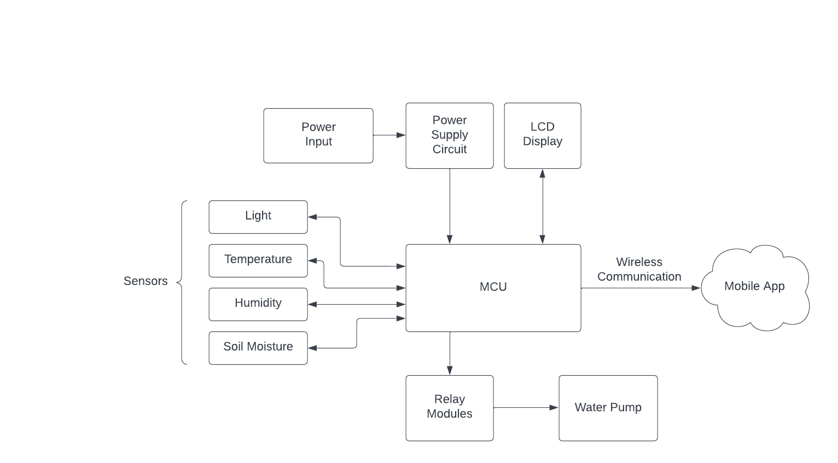

**Fig. 3: Hardware Block Diagram**

**4. Estimated Project Budget and Financing**

|  |  |  |
| --- | --- | --- |
| **Item** | **Quantity** | **Estimated Price** |
| Microcontroller | 1 | **$28.50** |
| Rechargeable Battery | 1 | **$8.28** |
| Custom PCB Board | 1 | **unknown** |
| Moisture Sensor | 1-4 | **$9.99** |
| Humidity Sensor | 1-4 | **$10.29** |
| Ambient Light Sensor | 1-4 | **$16 - $64** |
| LCD Display | 1 | **$15.99** |
| Wi-Fi module | 1 | **$8.52** |
| Water Pump | 1 | **$14.99** |
| Water Valves | 1-4 | **$16.64** |
| Water Pipe [10 ft] | 1-4 | **$3.48 - $13.92** |
| Pots | 4 | **$21.98** |
| Self-made Enclosure | 1 | **unknown** |
| Garden Soil | 4-10 gallons | **$6.49 - $19.47** |
| PV Panels | 1 | **$4.38** |
| **Total** | | **$165.53 - $236.95** |

**Table 2: Estimate of cost based on known and estimated values**

**5. House of Quality**

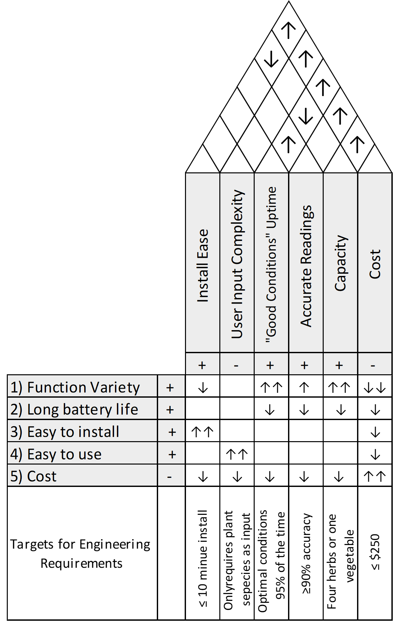

**Fig. 4: The House of Quality for the SMART Garden project**

**6. Initial Project Milestone**

**5.1 Senior Design I**

|  |  |  |  |  |
| --- | --- | --- | --- | --- |
| **Number** | **Task** | **Start** | **End** | **Status** |
| 1 | **Ideas** | 9/1/2022 | 9/06/2022 | Complete |
| 2 | Divide and Conquer I | 9/1/2022 | 9/16/2022 | Completed |
| 3 | **Role Assignments** | 9/3/2022 | 9/8/2022 | Complete |
| 4 | **Project Selection** | 9/5/2022 | 9/22/2022 | IP |
| 5 | Wireless Communication | 9/12/2022 | 9/30/2022 | IP |
| 6 | Schematics | 9/15/2022 | 9/30/2022 | IP |
| 7 | Microcontroller | 9/20/2022 | 10/04/2022 | IP |
| 8 | PCB Layout | 9/24/2022 | 10/08/2022 | Researching |
|  | **Research, Design and Development** |  |  |  |
| 9 | Power Supply | 9/26/2022 | 10/10/2022 | Researching |
| 10 | **Project Report** |  |  |  |
| 11 | First Draft | 10/1/2022 | 11/4/2022 | IP |
| 12 | Temperature Senor | 10/1/2022 | 10/20/2022 | Researching |
| 13 | UV Sensor | 10/1/2022 | 10/20/2022 | Researching |
| 14 | Humidity Senor | 10/1/2022 | 10/20/2022 | Researching |
| 15 | Soil Moisture Sensor | 10/1/2022 | 10/20/2022 | Researching |
| 16 | Analog to Digital Converter (if applicable) | 10/10/2022 | 10/25/2022 | Researching |
| 17 | **Order all parts and test them** | 10/20/2022 | 11/15/2022 | Researching |
| 18 | Final Draft | 11/1/2022 | 11/21/2022 | Researching |
| 19 | Second Draft | 11/4/2022 | 11/18/2022 |  |

**Table 3: Milestones during Senior Design I. ‘IP’ designates tasks still in progress.**

**5.2 Senior Design II**.

|  |  |  |  |  |
| --- | --- | --- | --- | --- |
| **Number** | **Task** | **Start** | **End** | **Status** |
| 1 | **Build Prototype** | TBD | TBD |  |
| 2 | **Redesign if needed and Testing** | TBD | TBD |  |
| 3 | **Final Prototype** | TBD | TBD |  |
| 4 | **Peer Review** | TBD | TBD |  |
| 5 | **Final Report** | TBD | TBD |  |
| 6 | **Final Presentation** | TBD | TBD |  |

**Table 4: Milestones during Senior Design II**

**7. Conclusion**

In conclusion, the goal of this project is to design and build a fully functional Smart Garden. This device will be portable and easy to use and have features such as light, temperature, humidity, and soil moisture detection. These peripherals matched with the UI for the end user will provide a great user experience which optimizes the way the general public grows and harvests plants. This system allows for more time to be spent doing higher priority needs while still allowing the end user to enjoy the many benefits of growing your own plants. It will be made user friendly through the implementation of a mobile app or web application which will display all gathered data, as well as offer scheduling capabilities for a built-in automated watering system. This device will give users a cost friendly gardening option in hopes of increasing access to healthy food alternatives.